<!--This file created 2:29 PM 10/29/97 by Claris Home Page version 2.0-->4.7 Project
Locating Critical Points and Inflection Points

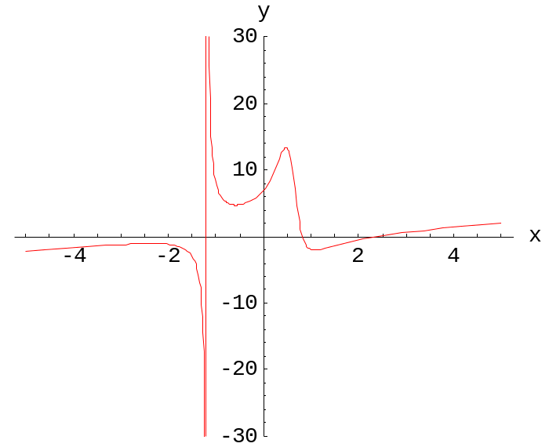

This project is about locating the critical points and the inflection points on a given graph 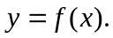 Here we illustrate the use of various technologies for this purpose by analyzing the graph of the function

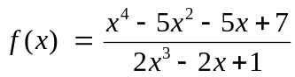 (1)

that is shown in the figure above. (See Example 8 in Section 4.7 of the text for further discussion.) This graph appears to have several critical points and several inflection points as well as a vertical asymptote.

We will see that the denominator 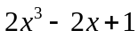 in Eq. (1) has a single real zero near x = –1.1915, and this provides the location of the vertical asymptote. To find the critical points on the graph, we need first to calculate the first derivative

 (2)
Because a fraction vanishes only if its numerator vanishes, the horizontal tangent lines to the graph  occur at the (real) zeros of the numerator, and thus where

(3)

To find the inflection points on the graph, we need to calculate the second derivative

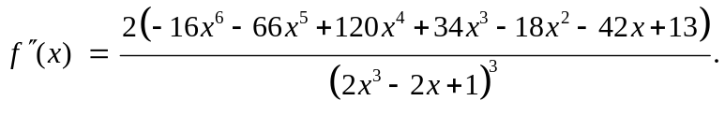 (4)

Then the possible inflection points on the graph are those points where the numerator in (4) vanishes, so

(5)

Thus our task of finding all the critical points and possible inflection points on the graph boils down to finding the real solutions of Equations (3) and (5). Having done this, we can plot the graph near each such special point to determine visually whether it is a local maximum or minimum point or an actual inflection point.

We will illustrate this procedure using typical calculating and computing systems. Having worked through these illustrative computations, you should be prepared to apply the same techniques to the investigations assigned in Project 4.7 in the text.
Using a Graphing Calculator
We have seen that the vertical asymptote of the function  in (1) above is given by the roots of its denominator polynomial 2x³ – 2x + 1, while

- its critical points are given by the roots of the polynomial  in (3) that is the numerator of the first derivative 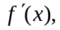 and
- the possible inflection points of are the roots of the polynomial 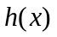 in (5) that is the numerator of the second derivative 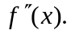

In order to use a TI-83 (for instance) to locate these special points on the graph , we first define these three polynomials. The following calculator screen shows them defined as Y1, Y2, and Y3, respectively.



The Asymptote
When we plot the graph of Y1 = 2x³ – 2x + 1 for 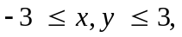 we see the following graph:

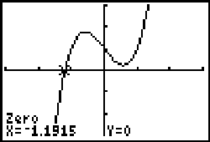

We have already used 2nd CALC zero to locate the single x-intercept. Thus the curve has the single vertical asymptote with approximate location x = –1.1915.
The Critical Points
When we plot the graph of Y2 = for 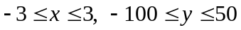 we see the following graph:

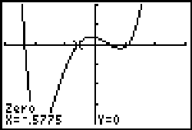

Four real solutions of 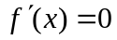 are visible, and we have already used 2nd CALC zero to find that the second of these is approximately x = –0.5775. In order to calculate the ordinate of the corresponding critical point on the curve , we also define Y4 =. Then evaluation of X and Y4 — as indicated in the calculator screen at the top of page 4 — yields the critical point (–0.5775, 4.7074). Now the denominator
(2x³ – 2x + 1)² of  is positive. Because the graph of the numerator above therefore shows that is negative to the left and positive to the right, it follows from the first derivative test shows that this is a local minimum point.

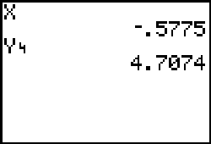

Exercise 1 Show similarly that the other three critical points on the graph are the local maximum points (–2.3440, –1.0681) and (0.4673, 13.4304), and the local minimum point (1.0864, –2.1128).

Alternatively, you can use the solve function (entered from the CATALOG menu) if you want to find the abscissa of all four critical points immediately. In the following screen we have read the initial estimates x = –2, x = –0.5, x = 0.5, and x = 1 from the graph of above.

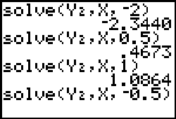

The Inflection Points
We must work some with the y-scale in order to see the "whole graph" of 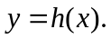 When we plot the graph of Y3 = for we see the picture

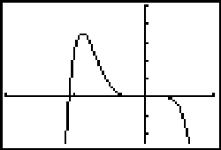

which shows one root just to the left of x = –5 and some more "action" near the origin. With 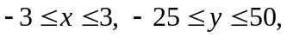 we get the picture

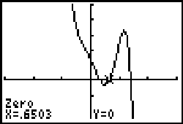

which shows three positive roots. We have already used 2nd CALC zero to find that the second of these is approximately x = 0.6503. Then evaluation of Y4 yields the corresponding ordinate 7.2690. Thus the corresponding possible inflection point on the graph is (0.6503, 7.2690). Now the graph of Y1 = 2x³ – 2x + 1 above shows that the denominator (2x³ – 2x + 1)³ of 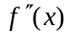 is positive for x > 0. Because the graph of the numerator above therefore shows that is negative to the left and positive to the right, it follows (why?) shows that this is an inflection point where the graph is concave downward to the left and concave upward to the right.
Exercise 2 Show similarly (or using the solve function) that the other three roots of yield the three inflection points (–5.4303, 2.4522), (0.3152, 11.4232), and
(1.3937, –1.6289) on the graph 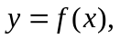 and check the concavity of the graph to the left and right of each.

Using Maple

First we define the function .
f := x -> (x^4-5*x^2-5*x+7)/(2*x^3-2*x+1):
Then we can let Maple proceed to calculate the first derivative
Dy := simplify(D(f)(x));
and the second derivative
D2y := simplify(D(D(f))(x));
The Asymptote
To find the asymptote, first let us pick out the denominator of .
denominator := denom(f(x));

denominator := 2*x^3-2*x+1
It zeros are given by
fsolve(denominator = 0, x, complex);

-1.19149, .595744-.254426*I, .595744+.254426*I

and we see the single real zero x = –1.19149 that gives the location of the vertical asymptote.
The Critical Points
We must find the real zeros of the numerator
g := x -> numer(Dy);
g(x);
2*x^6+4*x^4+24*x^3-32*x^2+9-10*x

of the derivative . Its zeros are given by
zeros := [fsolve(g(x) = 0, x, complex)];

zeros := [-2.34399, -.577489, .467291, .683912-2.46595*I, .683912+2.46595*I, 1.08636]

We see that the first three and the last of these zeros are real.
realzeros := [op(zeros[1..3]),zeros[6]];

realzeros := [-2.34399, -.577489, .467291, 1.08636]

The respective ordinates of the corresponding critical points on the graph are given by
ordinates := map(f, realzeros);

ordinates := [-1.06809, 4.70742, 13.4304, -2.11277]

These four critical points themselves are defined by
critPoint := i -> [realzeros[i],ordinates[i]]:
For instance, the second of these four critical points has xy-coordinates given by
critPoint(2);
[-.577489, 4.70742]
and the graph
plot(f(x), x=-0.7..-0.4);
shows that it is a local minimum point.
The Inflection Points
Now we must find the real zeros of the numerator
h := x -> numer(D2y);
h(x);
26-84*x+68*x^3+240*x^4-36*x^2-32*x^6-132*x^5

of the second derivative Its zeros are given by
zeros := [fsolve(h(x) = 0, x, complex)];

zeros := [-5.43025, -.526977-.495982*I, -.526977+.495982*I, .315246, .650294, 1.39367]

We see that the first and the last three of these zeros are real.
realzeros := [zeros[1],op(zeros[4..6])];

realzeros := [-5.43025, .315246, .650294, 1.39367]

The respective ordinates of the corresponding inflection points on the graph are given by
ordinates := map(f, realzeros);

ordinates := [-2.45219, 11.4233, 7.26907, -1.62893]

These four inflection points themselves are defined by
inflectPoint := i -> [realzeros[i],ordinates[i]]:
For instance, the third of these four inflection points has xy-coordinates given by
inflectPoint(3);
[.650294, 7.26907]
and the graph
plot(f(x), x=0.5..0.8);
verifies that it is an inflection point — concave downward to the left and concave upward to the right.

Using Mathematica

First we define the function .
f[x_] := (x^4 - 5*x^2 - 5*x + 7)/(2*x^3 - 2*x + 1)
Then we can let Mathematica proceed to calculate the first derivative
Dy = Together[D[f[x], x]]
and the second derivative
D2y = Together[D[f[x], x,x]]
The Asymptote
To find the asymptote, first let us pick out the denominator of .
denom = Denominator[f[x]]

1 - 2 x + 2 x^3
Its zeros are given by
NSolve[denom == 0, x]

{{x -> -1.19149}, {x -> 0.595744 - 0.254426 I},
{x -> 0.595744 + 0.254426 I}}
and we see the single real zero x = –1.19149 that gives the location of the vertical asymptote.
The Critical Points
We must find the real zeros of the numerator
g[x_] = Numerator[Dy]

9 - 10 x - 32 x^2 + 24 x^3 + 4 x^4 + 2 x^6
of the derivative . Its zeros are given by
zeros = NSolve[g[x] == 0, x]

{{x -> -2.34399}, {x -> -0.577489}, {x -> 0.467291},
{x -> 0.683912 - 2.46595 I},
{x -> 0.683912 + 2.46595 I}, {x -> 1.08636}}
We see that the first three and the last of these zeros are real.
realZeros = zeros[[{1, 2, 3, 6},1,2]]

{-2.34399, -0.577489, 0.467291, 1.08636}
The corresponding points on the graph are tabulated by
critPoints =
Table[{realZeros[[i]], f[realZeros[[i]]]}, {i, 1, 4}]

{{-2.34399, -1.06809}, {-0.577489, 4.70742},
{0.467291, 13.4304}, {1.08636, -2.11277}}
Each (horizontal) row of this 4-by-2 array provides the coordinates 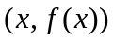 of a critical point on the graph. For instance, the second of these points has xy-coordinates given by
critPoints[[2]]

{-0.577489, 4.70742}
and the graph
Plot[f[x], {x, -0.7, -0.4}];
shows that it is a local minimum point.
The Inflection Points
Now we must find the real zeros of the numerator
h[x_] = Numerator[D2y]

-2 (-13 + 42 x + 18 x^2 - 34 x^3 - 120 x^4 + 66 x^5 +
16 x^6 )
of the second derivative . Its zeros are given by
zeros = NSolve[h[x] == 0, x]

{{x -> -5.43025}, {x -> -0.526977 - 0.495982 I},
{x -> -0.526977 + 0.495982 I}, {x -> 0.315246},
{x -> 0.650294}, {x -> 1.39367}}
We see that the first and the last three of these zeros are real.
realZeros = zeros[[{1, 4, 5, 6},1,2]]

{-5.43025, 0.315246, 0.650294, 1.39367}
The corresponding points on the graph are tabulated by
inflectPoints =
Table[{realZeros[[i]], f[realZeros[[i]]]}, {i, 1, 4}]

{{-5.43025, -2.4522}, {0.315246, 11.4232},
{0.650294, 7.26901}, {1.39367, -1.62892}}
Each row of this 4-by-2 array provides the coordinates of an inflection point on the graph. For instance, the third of these points has xy-coordinates given by
inflectPoints[[3]]

{0.650294, 7.26901}
and the graph
Plot[f[x], {x, 0.5, 0.8}];
verifies that it is an inflection point — concave downward to the left and concave upward to the right.

Using MATLAB

First we define the function .
syms x
f = (x^4-5*x^2-5*x+7)/(2*x^3-2*x+1);
Then we can let MATLAB proceed to calculate the first derivative
Dy = simple(diff(f,x))

(2*x^6+4*x^4+24*x^3-32*x^2+9-10*x)/(2*x^3-2*x+1)^2
and the second derivative
D2y = simple(diff(f,x,2))

-2*(-13+16*x^6+42*x-34*x^3+66*x^5+18*x^2-120*x^4)/(2*x^3-2*x+1)^3
You can use the commands pretty(Dy) and pretty(D2y) to see these fractions printed in nicely built-up form.
The Asymptote
To find the asymptote, first let us pick out the denominator of .
[numer,denom] = numden(f);
denom

denom =
2*x^3-2*x+1

It zeros are given by
zeros = solve(denom);
zeros = double(zeros)

zeros =
-1.1915
0.5957 - 0.2544i
0.5957 + 0.2544i
and we see the single real zero x = –1.1915 that gives the location of the vertical asymptote.
The Critical Points
We must find the real zeros of the numerator
[numer,denom] = numden(Dy);
numer

numer =
2*x^6+4*x^4+24*x^3-32*x^2+9-10*x

of the derivative . Its zeros are given by
zeros = solve(numer);
zeros = double(zeros)

zeros =
-2.3440
-0.5775
0.4673
0.6839 - 2.4659i
0.6839 + 2.4659i
1.0864
We see that the first three and the last of these zeros are real.
realzeros = zeros([1,2,3,6])

realzeros =
-2.3440
-0.5775
0.4673
1.0864

The respective ordinates of the corresponding critical points on the graph are given by
ordinates = double(subs(f,x,realzeros))

ordinates =
-1.0681
4.7074
13.4304
-2.1128

These four critical points themselves are defined by
critPoints = [realzeros,ordinates]

critPoints =
-2.3440 -1.0681
-0.5775 4.7074
0.4673 13.4304
1.0864 -2.1128
For instance, the second of these four critical points has xy-coordinates given by
critPoints(2,:)
ans =
-0.5775 4.7074
and the graph
ezplot(f,[-0.7 -0.4])
shows that it is a local minimum point.
The Inflection Points
Now we must find the real zeros of the numerator
[numer,denom] = numden(D2y);
numer

numer =
26-32*x^6-84*x+68*x^3-132*x^5-36*x^2+240*x^4

of the second derivative . Its zeros are given by
zeros = solve(numer);
zeros = double(zeros)

zeros =

-5.4303
-0.5270 - 0.4960i
-0.5270 + 0.4960i
0.3152
0.6503
1.3937

We see that the first and the last three of these zeros are real.
realzeros = zeros([1,4,5,6])

realzeros =
-5.4303
0.3152
0.6503
1.3937
The respective ordinates of the corresponding inflection points on the graph are given by
ordinates = double(subs(f,x,realzeros))

ordinates =
-2.4522
11.4232
7.2690
-1.6289
These four inflection points themselves are defined by
inflectPoint = [realzeros,ordinates]

inflectPoint =
-5.4303 -2.4522
0.3152 11.4232
0.6503 7.2690
1.3937 -1.6289

For instance, the third of these four inflection points has xy-coordinates given by
inflectPoint(3,:)
ans =
0.6503 7.2690

and the graph
ezplot(f,[0.5 0.8])
verifies that it is an inflection point — concave downward to the left and concave upward to the right.

